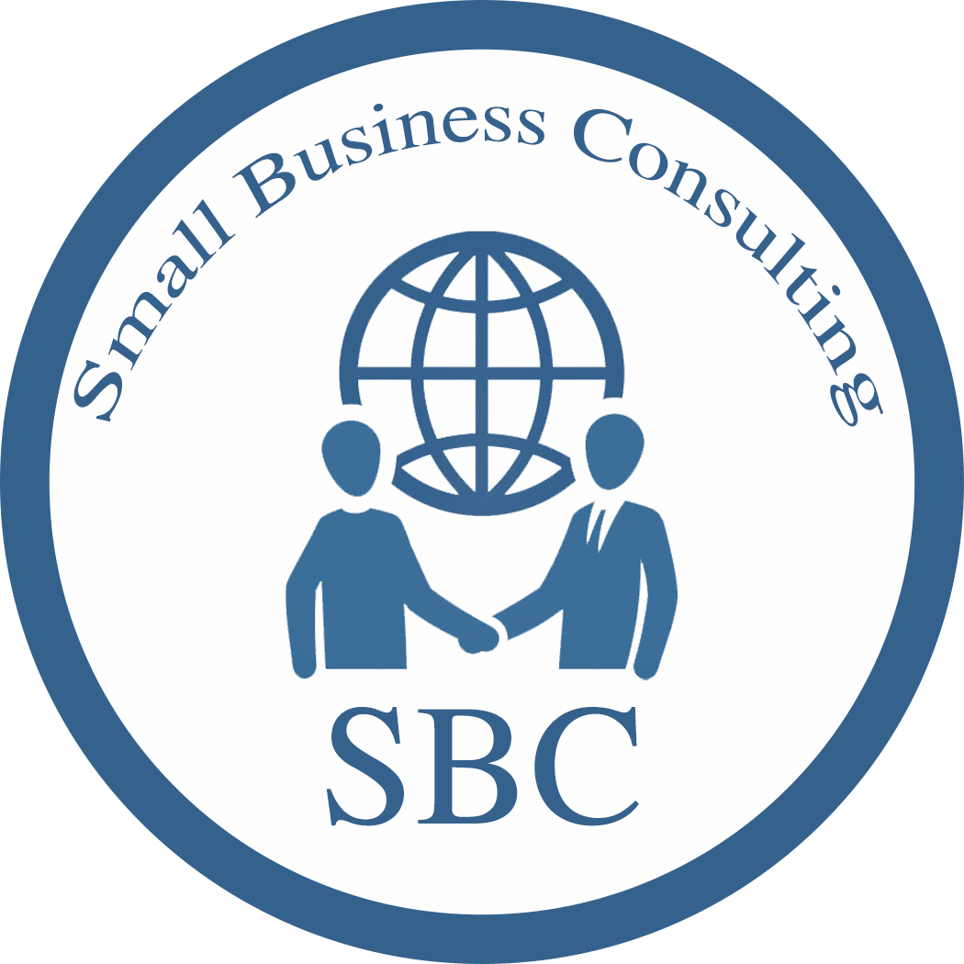

Small Business Consulting
4567 Kona Springs Dr , Suite 578
San Diego , CA , 92124
Phone number: (619) 416-0000
info@SBC.ORG

Project Title
Lowering Tax for Small Businesses
Prepared for : Internal Revenue Service

Prepared by : Small Business Consulting

Description
Small Business Consulting firm conducted a study to the IRS that shows the reasons for lowering taxes on small businesses, and how it will result in increasing the country’s GDP. By lowering the taxes, the number of small businesses will increase, job opportunities, and unemployment will decrease.

Table of Contents

Executive Summary …………………………………………… 1

Study Methodology ……………………………....................... 1

Benefits ……………………………………………. 2

Small Business Consulting

Executive Summary

Small Business Consulting firm conducted a study to the IRS that shows the reasons for lowering taxes on small businesses. And how it will result in increasing the country’s GDP. By reducing the taxes, the number of small businesses will increase job opportunities, and unemployment will decrease. This report shows the current tax rate the IRS imposes on small businesses. Also, it shows our study methodology on taxes in the USA and what is the ideal tax rate for small businesses .

sTUDY Methodology

We assume that “ $125,000” is the average income of the small business per year. We found this number after looking into small business income statements around the country, and we found that $125,000 is the average income.

Business Structures | TAX rate before deduction  % | The amount of money on the rate now | TAX rate after Deduction  % | The amount of money on the rate after deduction
Sole Proprietorship | 13.3% | $108,375.00 | 9.2% | $113,500.00
Partnership | 23.6% | $95,500.00 | 16.5% | $104,375.00
Corporation | 21% | $98,750.00 | 14.7% | $106,625.00

We decrease 30% of tax rate because we assume that the best way to create a free cash flow to grow the business and also expand. We consider that 30% will save the currency from inflation and keep both GDP and the economy reserve high, which will influence a better economy in the USA.

Small Business Consulting
For Example : A Taco shop , with a Sole proprietorship statement per month. Green Table shows profit with the current TAX rate. Brown table shows profits with the new tax rate.
$125,000/ 12 months = $10,416 per month
Brown Table
Total income | (-) expenses |  |  |  | (=) profit
income per month | TAX  9.2% | employee salary (2 employee x$7.25 X 8 H/D  x 30 Days | Operation cost | supplies | profit per  month
$10,416.00 | ($958.00) | ($3,480.00) | (800) | (1000) | $4,178.00

Green Table
Total income | (-) expenses |  |  |  | (=) profit
income per  month | TAX  13.3% | employee salary (2 employee x$7.25 X 8 H/D  x 30 Days | Operation cost | supplies | profit per  month
$10,416.00 | ($1,385.00) | ($3,480.00) | (800) | (1000) | $3,752.00

* $7.25 is the average wage in the USA

- We found out after comparing the current TAX rate (Green Table) and the proposed TAX rate (Brown table) that there is a $426 per month more cash in the proposed TAX. As a result, there will be $5,112 annually, which gives the owner more freedom to develop the business and to create more jobs.

Benefit
. Increasing the GDP of the economy, because there will be more goods and services sold.
. Creates more jobs in the market: by growing the business more jobs will be needed
. Lower the inflation rate : when there is more money in the market the inflation rate decreases
. Involving more foreign investors: foreign investors will be encouraged to invest in countries with a low tax rate.

Small Business Consulting

