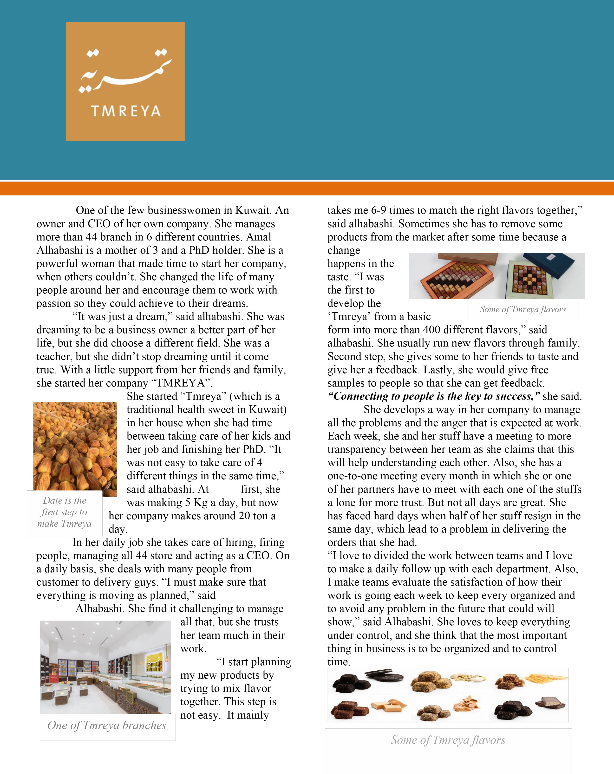
“It was just a dream”
Amal Alhabashi

She thinks that the most important factor in a business is the writing, in which everyone must understand what is needed. People in one company may deal with others in different time of the day in different countries so as to save time. All writing must be simple and direct to the point for more growth in the company as she expected from her stuff. She also deals with people from outside: customers, suppliers, and other company’s and all communication must be in writing, so everyone knows what is needed and wanted.
Every day, she deals many writing like
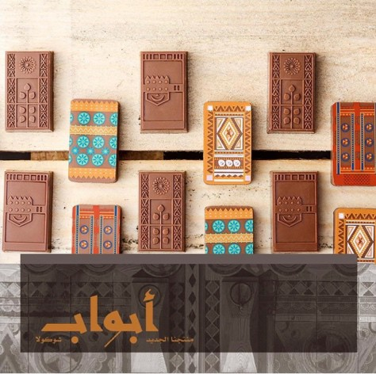reports and emails. In a normal day she gets more than 60 emails from customers, branches, factory, and others, and

One of Tmreya new product (chocolate design to show the old doors in the gulf area)
person in a task makes the task much easy. She always asks to choose wisely because that what makes a business a success as she claims and she proof it in her business. She chooses a person for the job and the then she only follows up from time to time which make it easier.
“Networking is one of the important things in business,”
alhabashi said. she claims that you will be introduce to new people that will help in your business from suppliers. Her advice is that

whenever you have the chance to go to a networking
event you must go so you that could find what you are missing and people could find what they need in you.

she has to reply and deal with all of them. “Get to
She also wants to give an advice for student and newemployee that entering the field. She asks them to
One of Tmreya new product (chocolate

the point and to make it short and
simple for every person to understand,” said alhabashi. These are some of the techniques she uses in writing. “I use different tone when dealing with different people,” alhabashi said. She claims that when she deals with people that she shares moment in the company with will not be as if dealing with a customer that speak with him for the first time.
“We have to make a background search of the people’s culture you are dealing with,” alhabashi said. It is very important and for the best of all to make a few checks on what to include in an email or a contract are not, sometimes it may be offensive to the other person but you don’t know and could end blowing your deal.
Alhabashi want to be clear that every paper, email, contract must be in a legal way because you have to seek the best to the company and you must not make any gaps in the contract that could lead in making other take advantage. “It’s good to trust others but at the same time you must be careful, you do not know the intention of people,” said alhabashi.
“Put the right person in the best spot,” said alhabashi. She wants to show that choosing the right
follow their passion and never stop. Maybe they will fail today, but tomorrow is always better. She also shows how it is important to learn from mistakes and whenever they have the chance to have something better they must take it. In business the most important thing is to get the best for your company and also get the best experience for yourself.
“life is important but you also have to give your time to gain profit” she said.



A video for Tmreya store

